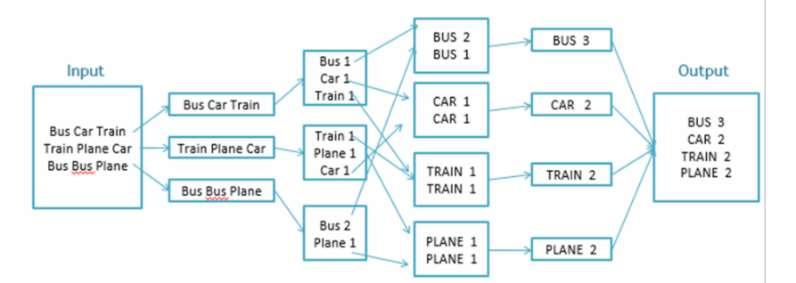

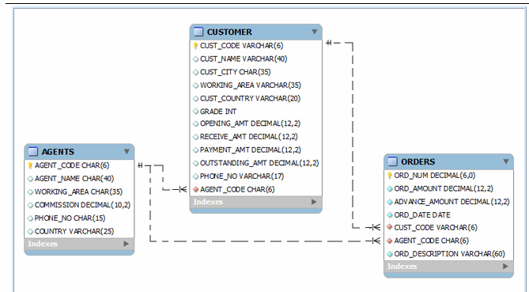

select cust_name from customer

where cust_code in

(select distinct cust_code

from orders

where

advance_amount = 0

or

advance_amount is null);

select agent_name from agents

where

agent_code not in

(

select distinct agent_code from orders

);

select * from agents

where country is null

or trim(country) = ''

or trim(country) = ' ';